Cylindrical gauge visual for representing the data in cylinder. It’s mainly used for showing water ratio in the container.

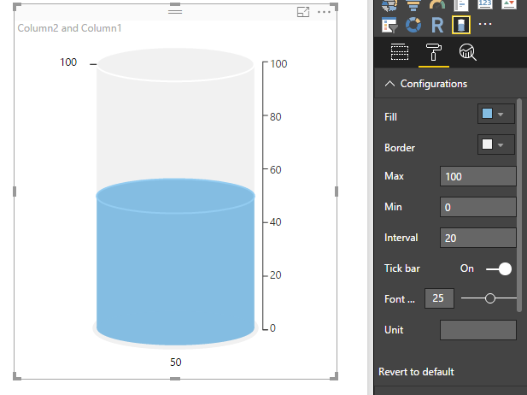

Fig. 1. Cylindrical gauge

**Configurations:**

1. Fill: To set color of inner part of the cylinder (e.g. water color)
2. Border: To set border color of cylinder (e.g. container color)
3. Max: To set maximum threshold of cylinder
4. Min: To set minimum threshold of cylinder
5. Interval: To set interval length for tick labels
6. Tick bar: To enable or disable the cylinder labels (indicators)
7. Font Size: To change the font-size of labels
8. Unit: To set a unit to be displayed with values
9. Show Target: To enable or disable the target marker
10. Target Color: To set color of target marker

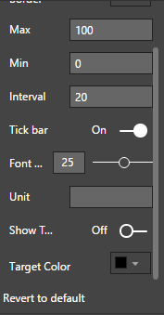

Fig. 2. Configurations

**A. Units**

1. User can provide unit in "Unit" format option.

2. This unit is concatenated to the actual value, target value and the tick labels.

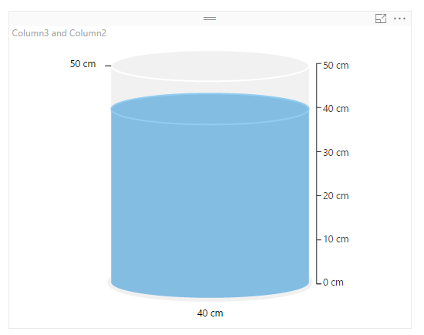

Fig. 3. Cylindrical gauge with units

**B. Target marker**

**1**. There is a Show Target format option, enabling which, user can see a marker of target value.

2. User can also change the color of marker**.**

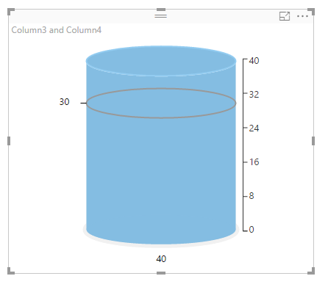

Fig. 4. Cylindrical gauge with target marker

**C. Color**

1. User can change the color of cylinder from the Configurations**.**

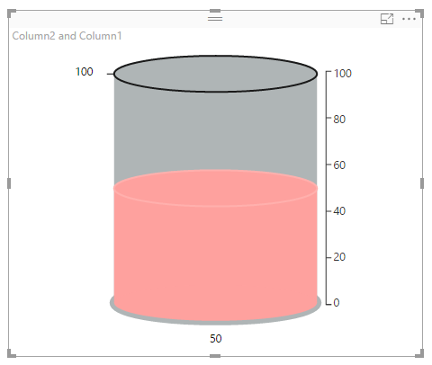

Fig. 5. Cylindrical gauge in different colors

**D. Interval**

1. User can explicitly provide the interval length to display the ticks and tick labels in the chart.

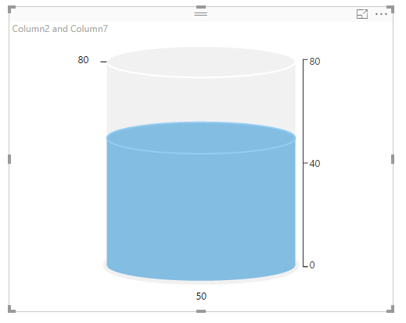

Fig. 6. Cylindrical gauge with interval length entered by user

**E. Tick labels**

1. User can disable the Tick bar format option to hide the ticks and tick labels.

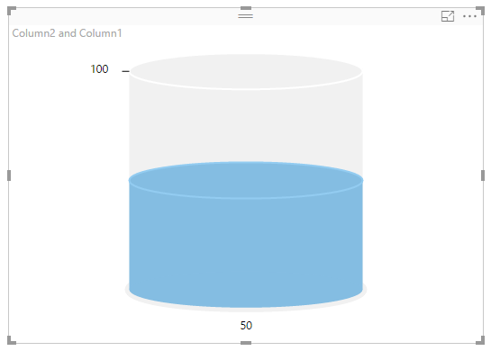

Fig. 7. Cylindrical gauge with Tick labels disabled

**F. Scroll Bar**

1. We can scroll down to see the whole cylindrical gauge in case the height of the visual is less.
2. In the below chart, scroll bar appears to view the whole visuals.

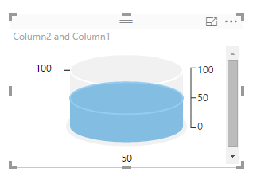

Fig. 8. Cylindrical gauge with scroll bar